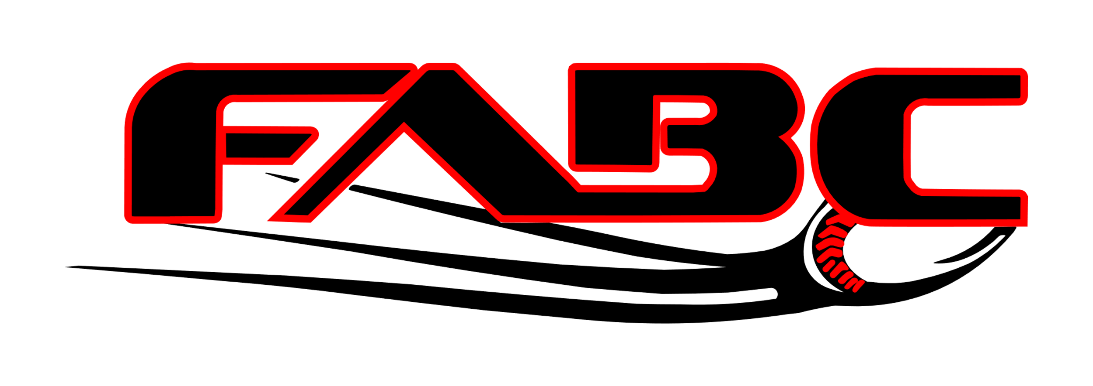

Farmington Amateur Baseball Congress
PO Box 1121
Farmington, NM 87499

The ____________________is a youth baseball team that will be participating with Farmington Amateur Baseball Congress (FABC). Your company’s sponsorship of _______would be a great contribution to the community youth that participate in the FABC. Thank you in advance for your contribution.

Please make checks payable to Farmington Amateur Baseball Congress with the team name _________________________ in the memo line.

Thank you!

FABC

For questions or concerns please refer to our website for contact details.

fabc.us

Tax Exempt Organization Number: 501 (c) (3) 85-0245173

